**Ch21.7**

**Assignment**

**Step 1: partitioning**

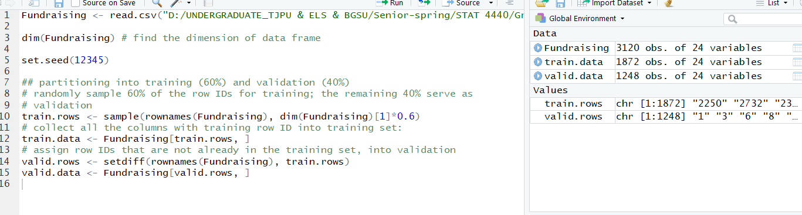

**Step 2: model building**

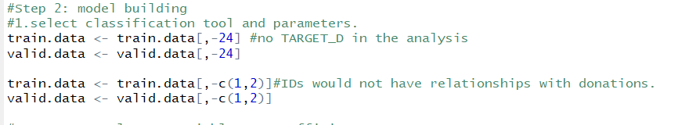

**#1. Select classification tool and parameters.**

May be we need to do PCA or DA firstly for reducing the dimensions cause troubles in the 2nd and 3rd method?

**1st Classification and regression trees**

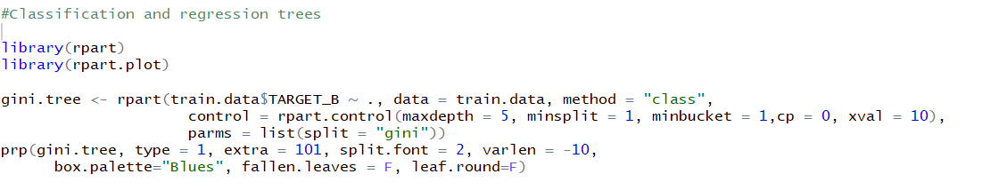

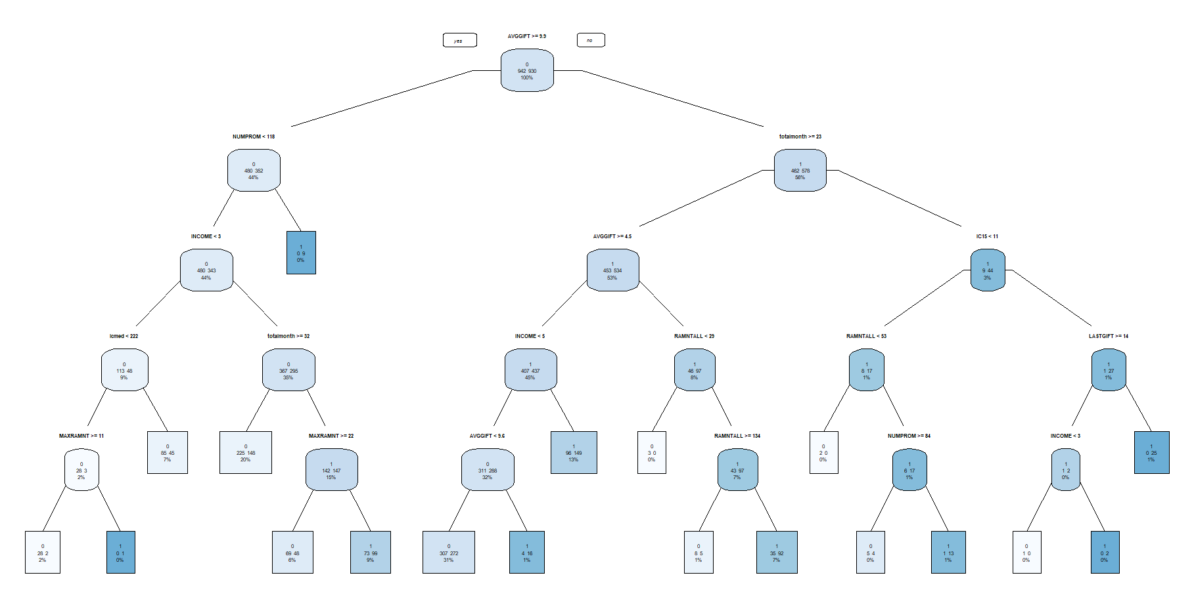

**2nd Logistic Regression**

We need to select variables from the 20 variables and then, test them one by one. That needs a lot of works. So, pass this.

**3rd Naive Bayes**

The reason is the same one.

**4th k-nearest neighbours**

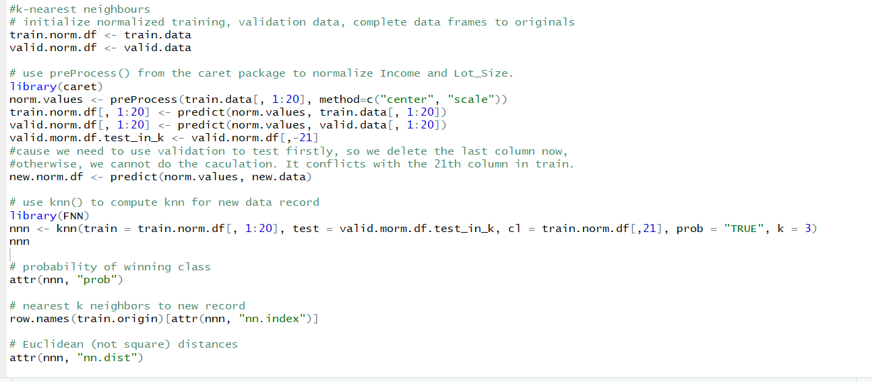

The results are too long to put here, but we will upload the codes.

**#2 Classification under asymmetric response and cost.**

**#3 Calculate net profit**

